MDCT 1
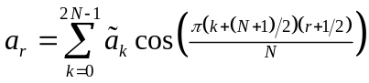
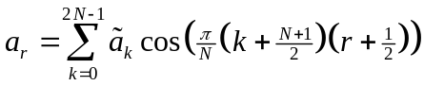
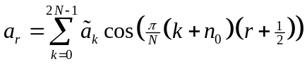, 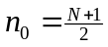
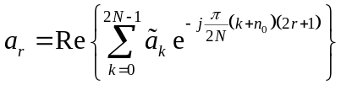
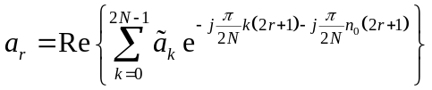
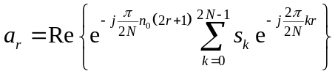, 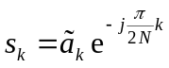 (Pre-twiddling)
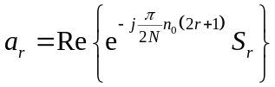, 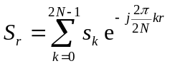, 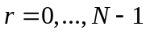 (FFT)
Let  be time the domain samples and  the frequency domain ones. Due to the decimation property, we have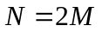. So:
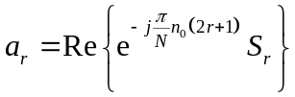, 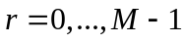 and 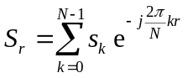 (FFT)
MDCT 2
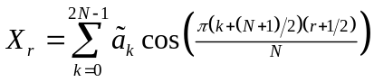
,
, (Pre-twiddling)
, , (FFT)
Let be time the domain samples and the frequency domain ones. Due to the decimation property, we have. So:
, and (FFT)
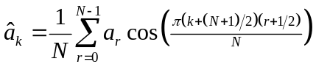, 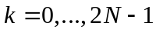
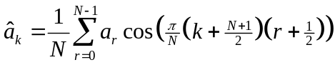
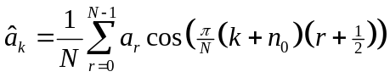,
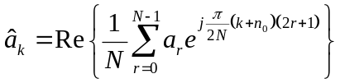
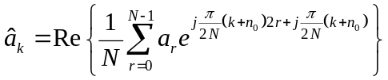
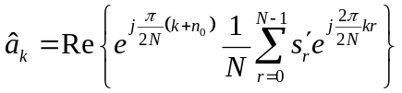, 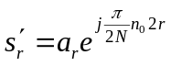 (Pre-twiddling)

MDCT
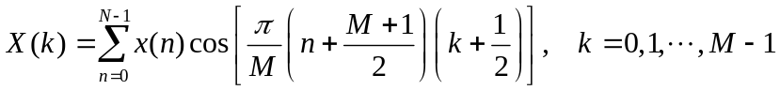

IMDCT
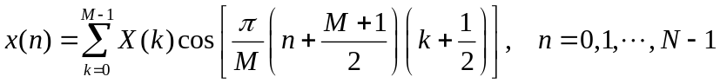

Window properties
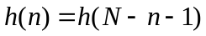
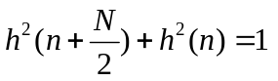

Windows
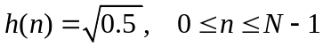
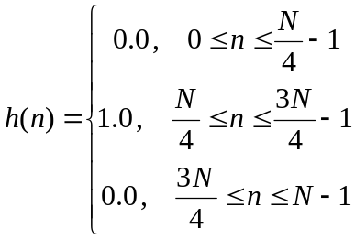
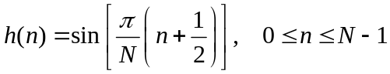
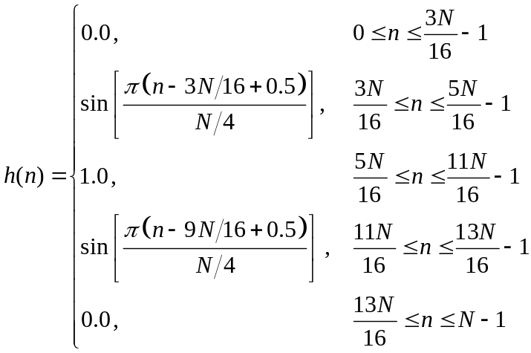
MDCT Simple Loop Derivation
, 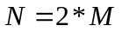

IMDCT Simple Loop Derivation

